Activity 6  
What is the Universe Made of?

Almost 14 billion years ago, the early universe was an incredibly hot, dense mixture of light and subatomic particles, such as protons and electrons. Approximately 380 000 years after the Big Bang, the properties of the universe changed and the light began to travel freely through space. Today, astronomers can observe this faint signal of light which is called the cosmic microwave background (CMB). The CMB contains a wealth of information about the properties of the cosmos.

In this activity, you will analyze the relationship between the CMB and sound waves in the early universe. You will also analyze what the CMB tells us about the composition of the universe. But first, we will look at how we can analyze complex sound waves.

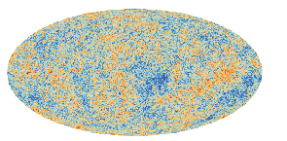

Figure 1 The CMB as seen by the Planck space telescope. Red regions are slightly hotter parts of the sky and blue regions are slightly colder.

Part 1: Adding and Subtracting Waves

When you strike a tuning fork, you generate a sound wave that has a single frequency (Figure 2(a)). You can see how the wave’s amplitude changes as the tuning fork vibrates. However, most sounds are a superposition of waves of many different frequencies, for example, the sounds produced by a trumpet (Figure 2(b)) and a pipe organ (Figure 2(c)).

|  |  |  |
| --- | --- | --- |
| Tuning Fork | Trumpet | Pipe Organ |
|  |  |  |

Figure 2 Amplitude versus time graph for various sources; (a) tuning fork, (b) trumpet, and (c) pipe organ

Any sound wave, no matter how complex, can be broken down into the different component frequencies using a mathematical technique called a Fourier transform. This method calculates which frequencies are present in the wave and their intensities. We can use a Fourier transform to generate a graph called a power spectrum. A power spectrum is an intensity-versus-frequency graph for the wave being analyzed.

We can use a flute as an example. Figure 3(a) shows the sound wave for a flute, and Figure 3(b) shows its power spectrum. The power spectrum shows four main frequencies that add together to produce the resultant wave. These frequencies are called harmonics.

|  |  |
| --- | --- |
| (a) Sound Wave | (b) Power Spectrum |
|  |  |

Figure 3 A flute’s (a) sound wave and (b) power spectrum.

1. Match the power spectrum with each instrument’s sound wave in Figure 4.

|  |  |  |
| --- | --- | --- |
| Tuning Fork | Trumpet | Pipe Organ |
|  |  |  |
|  |  |  |

Figure 4 Match the sound wave to its power spectrum.

1. Explain how the shape of a resultant wave can become complex (i.e. Fig 2(b) and (c)). In your explanation, draw two successive harmonic waves individually and as a sum.
2. Look at the flute’s power spectrum in Figure 3(b). What is the relationship between the frequencies of the second and third peaks to the frequency of the first peak? Predict the frequencies of the fifth and sixth peaks if they were present.
3. Hypothesize how the flute would sound if the intensity, or size of the first harmonic, were dramatically increased.

Part 2: The CMB and the Early Universe

The early universe was not perfectly uniform (smooth). It contained large quantities of light and various subatomic particles, such as protons and electrons. These particles tended to be found in small regions of higher and lower density. These differences in density generated sound waves that travelled through the early universe at 60% of the speed of light.

Approximately 380 000 years after the Big Bang, these sound waves were imprinted on the light present at that time. Today, cosmologists observe the CMB and use it to infer information about the nature of the universe.

Figure 5(a) is a map of the temperature fluctuations in the CMB across the sky. These small variations correlate with different pressures in the sound waves. So, the image is like a map of the sound waves in the early universe. Like any other wave, Figure 5(a) is a superposition of many different wavelengths. These wavelengths are represented in the power spectrum in Figure 5(b).

|  |  |
| --- | --- |
| a) Sound Wave | b) Power Spectrum |
|  |  |

Figure 5 (a) The CMB and (b) its power spectrum

Figure 6 illustrates how the initial peak of a sound wave expanded from just after the Big Bang to approximately 380 000 years after the Big Bang. Figure 6(c) shows how much the initial peak of the sound wave spread out by the time the light was released.

When the light was released, the average temperature of the universe was about 3000 K. The universe has expanded and cooled since then, and now has an average temperature of about 2.7 K (Figure 6(d)).



a) t = Just after Big Bang b) t = 190 000 years after c) t = 380 000 years after

d)

|  |  |
| --- | --- |
| **Age of the Universe** | **Temperature** |
| 380 000 Years Old | 3000 K |
| Present Day | 2.7 K |

Figure 6 Sound waves spread out after the Big Bang and travelled through the expanding universe. As the universe expanded, the temperature changed—the universe cooled. Each circle in the figure above represents a subatomic particle.

1. Using the data in Figure 6, calculate the wavelength of the first harmonic in the CMB, in light years. You will need the following information:

* The sound waves started shortly after the Big Bang and spread out at 60% the speed of light for 380 000 years
* Since the formation of the CMB, the universe and it have expanded. As the light travelled through the universe, it expanded too. The expansion factor can be calculated by comparing the temperatures of the current and past universe.
* The wavelength of the first harmonic is equal to the distance travelled by a sound wave. This quantity is double its expected value due to the symmetry of the wave.

1. Calculate the second and third harmonic wavelengths using the relationships from question 3 in Part 1.
2. How do the calculated wavelengths compare to the observed wavelengths in the power spectrum for the CMB below?



Part 3: The CMB’s Power Spectrum

The sound waves in the early universe are a result of the oscillation of the subatomic particles and light that was present. The different components of the universe affected the sound waves in different ways. Using scientific models, physicists have determined that if known subatomic particles and light were the only components of the early universe, there would be only one primary wavelength of oscillation, as shown in Figure 7(a).

|  |  |
| --- | --- |
| (a) CMB Power Spectrum if only known subatomic particles and light are present | (b) Observed CMB power spectrum |
|  |  |

Figure 7 (a) The CMB power spectrum if only subatomic particles and light were present; (b) the observed power spectrum for the CMB

1. Compare the two power spectra in Figure 7.
2. What features do they have in common? What features are different?
3. What physical phenomenon produces the large peak in both graphs?

(c) By comparing the two power spectra, what does this suggest about the universe? Choose the correct option, and explain your answer:

(i) Subatomic particles and light have extra, unknown properties

(ii) There is an additional but different type of matter in the universe

(iii)The two higher harmonics are echoes of the first harmonic

(iv) Our measuring instruments are distorted from interference somewhere in space

Dark Matter

Dark matter exerts gravity, so it attracts the oscillating light and subatomic particles that make up the sound waves. This affects the waves in an observable manner, allowing cosmologists to infer the presence of dark matter in the CMB.

Additional Differences

The CMB power spectrum in Figure 8 shows what we see (solid line) and what we would see if dark matter and ordinary matter were the only components of our universe (dashed line). The dashed line needs to be shifted toward the left to match up with the solid line to match observation with theory. This is a shift along the wavelength axis.

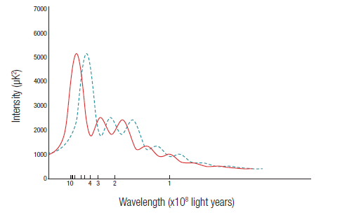

Figure 8 The CMB suggests one more missing constituent.

9. The dashed line needs to be shifted toward the solid line in Figure 8 (as described in the opening paragraph). Choose the correct answer below that will describe its transition:

(a) If we decrease the wavelength of each point along the dashed line, it will shift to the left

(b) If we increase the wavelength of each point along the dashed line, it will shift to the left

(c) If we decrease the intensity of each point along the dashed line, it will shift to the left

(d) If we increase the intensity of each point along the dashed line, it will shift to the left

10. Predict what will happen to a wave’s wavelength when the wave expands. Choose the correct answer and explain your choice.

(a) When a wave expands, its wavelength will increase

(b) When a wave expands, its wavelength will decrease

(c) When a wave expands, its wavelength will stay the same

(d) A wave’s wavelength is dependent on other factors

11. A star is observed to have a wavelength that is greater than expected. What does that tell us about it? Choose the most correct option.

(a) The star is running out of fuel

(b) The star is burning different, unexpected elements

(c) Something in the way is changing the star’s wavelength

(d) The star is moving away from us

12. A shift from the dashed line to the solid line can be interpreted as evidence of a larger than expected amount of expansion of the universe. Which component of the universe is responsible for this observation?

(a) Ordinary Matter

(b) Dark Matter

(c) Dark Energy

(d) Some other, new component that is yet to be discovered.

Summary

Analyzing the CMB has led cosmologists to the composition of the universe shown in Figure 9. The properties of these constituents have shaped the nature and evolution of the universe. Cosmologists can use the CMB to learn more about the formation of our present-day universe, calculate its age with greater precision, and perhaps even determine its ultimate fate. The CMB is arguably one of the most important observations in the history of cosmology.

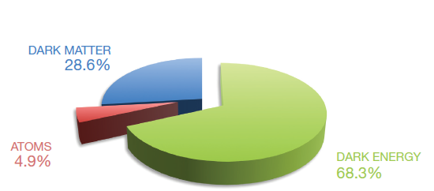

Figure 9 The relative abundances of the three main constituents of the universe